Programming Fundamentals

|  |  |
| --- | --- |
| **Student’s Name:** | Joaquin Jairo S. Abril |
| **Id. No:** | 2023462 |
| **Github Repository Name:** | Vending Machine |
| **Github Repository Link:** | https://github.com/JoaquinAbril/Vending-Machine |

**Repository Screen Shot:**

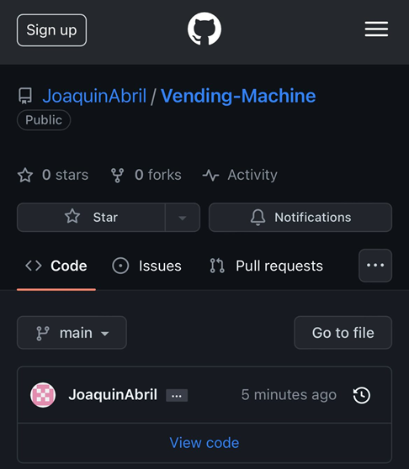

**ASSESSMENT 1&2**

| Contribution towards overall module mark | 100% (40%+60%) |
| --- | --- |
| Date set | September 5, 2022, |
| Marked work returned by | Within 3 weeks of submission |
| DEADLINES | Deadline : Jan 10, 2024– 23:59 |

**Brief**

I took a course called Intro to programming in the first semester of my BSc in Creative Computing. We had to create a vending machine program for the module's programming component. The program's needs and goals are described in full in this documentation paper. You may find the whole program needed to run it in the repository: https://github.com/JoaquinAbril/Vending-Machine

**Specification**

Products:

|  |  |  |  |  |
| --- | --- | --- | --- | --- |
| ID | Product | Price | Quantity | Description |
| A1 | Kangkong Chips | AED 14.99 | 999 | “Kangkong Chips ni Josh Mojica!" |
| A2 | Kwek Kwek | AED 2.50 | 43 | "Egg Waffles So Good!" |
| B1 | Heaven Tsokolit | AED 3.00 | 50 | "Unang Kagat, langit agad!" |
| B2 | Redhorse | AED 12.99 | 34 | "Redhorse! Extra Strong!" |
| C1 | Lechon | AED 75.00 | 12 | "Unang Subo, Highblood Agad! RAAAH!" |
| C2 | McLaren 720s | AED 9980.00 | 3 | "Prepare, Commit, Belong!" |
| D1 | Kathniel CB | AED 9999.00 | 1 | "She's Dating the Gangster 2" |
| D2 | Spotify Premium | 21.99 | 20 | "Music Wherever You Go!" |
| E1 | iPhone 15 Pro Max | 5499 | 6 | "Think Different!" |

These are the products that you may find in my vending machine program. The “ID” represents the button which product you like to select, the “Product” indicates the products you may choose and select the price is how much it cost. I also added “Quantity” wherein it indicates how many products are left in the vending machine finally; I added a unique feature in my vending machine which is “Description”, it describes the “Product” in a fun and unique way.

**System Flowchart**

When the user runs the program, a display is shown in the console wherein the user can choose four choices to use the vending machine; “1. Display Products”, “2. Insert Money”, “3. Purchase Product”, “4. Exit” There are two ways to use the vending machine I programmed because the user can choose to display the products (1) or insert the amount of money (2) first or vice versa and this will not disrupt the flow of the program. After choosing 1 or 2 that is displayed in the console the user can then purchase the product (3) after choosing and buying the product I programmed a loop wherein the

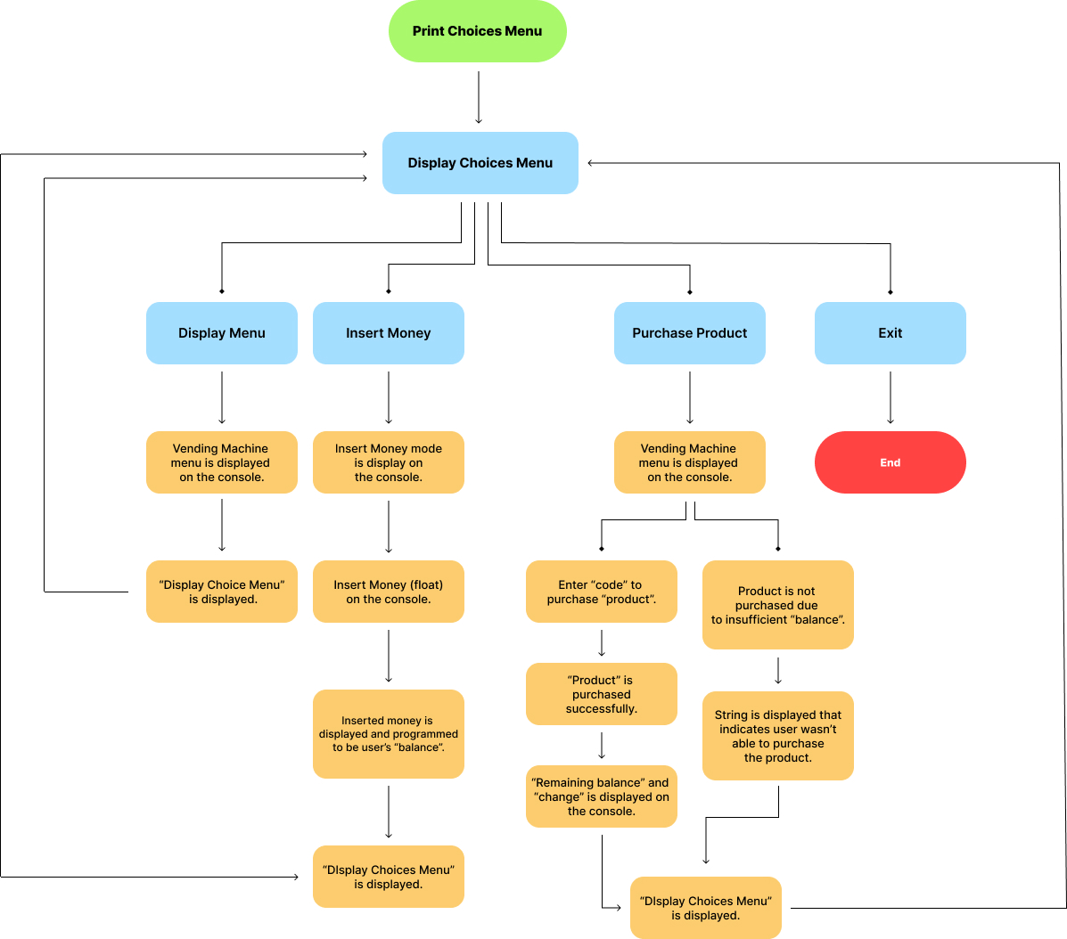

**Technical Description**

**Menu Data**

All of the code for the menu; “ID”, “Product”, “Price”, “Quantity”, “Description” are all listed inside a dictionary. The menu can only be accessed if you input “1” (1. Display Products) and “3” (3. Purchase Product) further explanation for the menu will be shown below. The “def” function is short for “define”. A keyword to be used to define a function/method the “def” function is used a lot of times to easily input the code between the “def” function. An example is “self” used multiple times in this specific screenshot, and will be later on used in other coding.

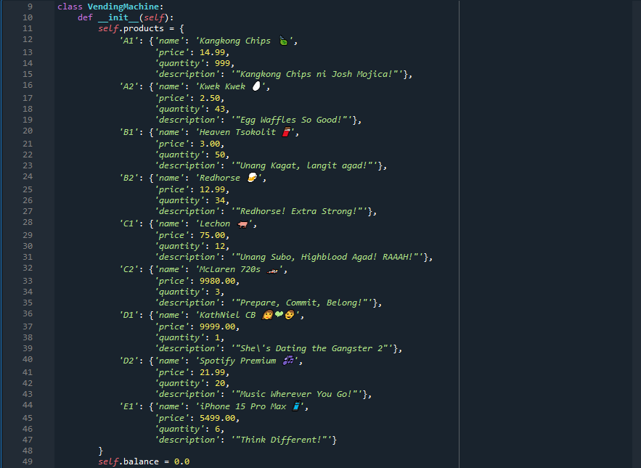

**Display Product Data**

The data code shown in the screenshot below appears on the console. The def function is inserted in a “for” function to easily input the code.

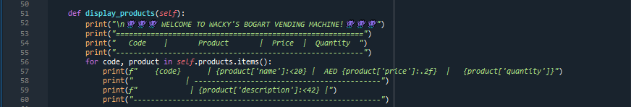

This is the program and what is shown on the console when you choose “1” (1. Display Product) on the display menu.

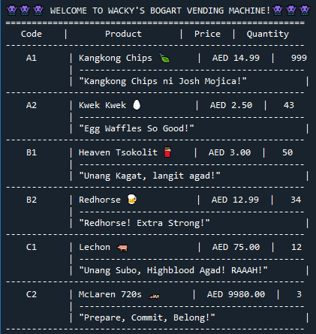

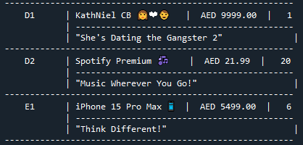

**Insert Money Data**

For this part of the segment, the code used is control flow statement. The “if” statement is used to identify the amount of “money” the user inputs on the console which greater than 0. If the input is greater than 0, the console prints the inserted amount of money and the user’s “current balance” in dirhams. “ValueError” is also added when the user inputs a string instead of a float to ensure the user inputs a float data type instead of a string data type.

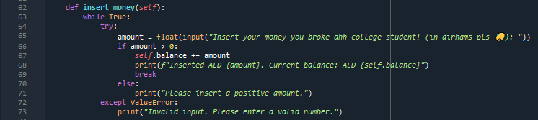

Displayed on console:

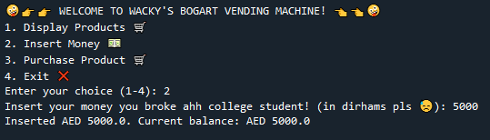

**Purchase Product Data**

The purchase product data code is easy as creating a python programmed calculator. Like in the other parts of the program the purchase product data uses control flow statements, dictionary, and the def function with only having the difference of input coded. There are two parts in this part. First is the “purchase_product”. If the user selects choice “3” the program shows the vending machine’s code on the console similar to the “Display Product Data” but the difference is the user is asked to input the “ID” shown from the menu. The second part is the “give_change”, it uses the “f-string” function to provide the user change.

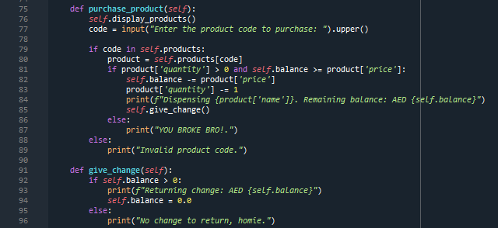

Purchase successful:



Purchase unsuccessful:



**Vending Machine Choice Menu Data**

The final part of the coding is actually the first thing the user sees when they run the program. A simple string data type combined with control flow statements. As you can notice, there are emojis present on the code in all screenshots provided.

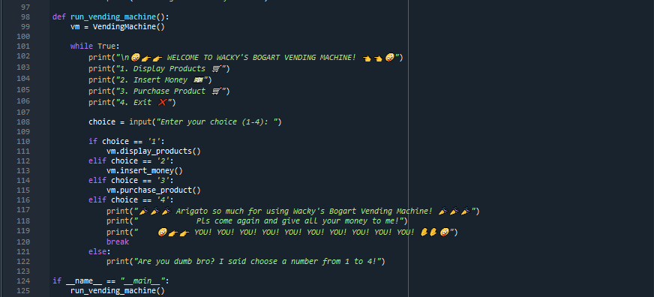

Display on console:

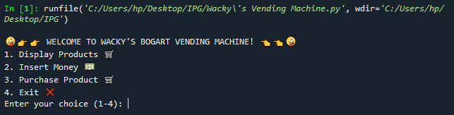

Exit display:

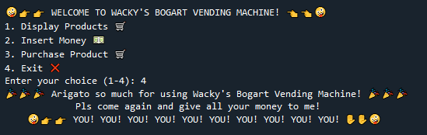

**Overview**

All in all, I mainly used dictionary, control flow statements and basic data types to create and finish my vending machine, with a little dash of my personality to make my program fun and enjoyable to use.

**Critical Reflection**

As a beginner, taking my first steps into the realm of programming through the Intro to Programming course was both exhilarating and enlightening. Throughout the course, the focus on Python programming opened up a world of possibilities and provided a solid foundation for understanding the fundamentals of coding.

One of the key aspects that struck me during the course was Python's readability and simplicity. As a language designed with the emphasis on clear and concise code, Python proved to be an excellent choice for beginners like myself. The syntax was intuitive, making it easier to grasp fundamental programming concepts without getting lost in complex syntax rules. This simplicity allowed me to focus on understanding the logic behind the code rather than being overwhelmed by intricate language details.

The hands-on approach of the course played a crucial role in reinforcing theoretical concepts. Through various coding exercises and projects, I had the opportunity to apply the principles learned in class. This practical experience was invaluable, as it not only solidified my understanding of Python but also cultivated problem-solving skills. Debugging became a natural part of the learning process, and overcoming coding challenges became a satisfying and rewarding experience.

The collaborative nature of the class fostered a sense of community among peers. Group projects and coding discussions encouraged the exchange of ideas and different approaches to problem-solving. The collaborative environment not only enriched my understanding of Python but also exposed me to diverse perspectives, enhancing my overall learning experience.

As the course progressed, I became increasingly aware of the importance of documentation and writing clean, maintainable code. Understanding how to create code that is not only functional but also comprehensible by others is a skill that will undoubtedly serve me well in future coding endeavors.

In conclusion, the Intro to Programming class provided a solid introduction to Python programming, laying the groundwork for a deeper exploration of the coding world. The combination of Python's readability, hands-on projects, collaborative learning, and exposure to its diverse applications made this course a valuable stepping stone in my journey as a programmer. Armed with newfound knowledge and a passion for coding, I look forward to applying these skills in future projects and continuing my exploration of the vast and exciting field of programming.

**Appendix**













